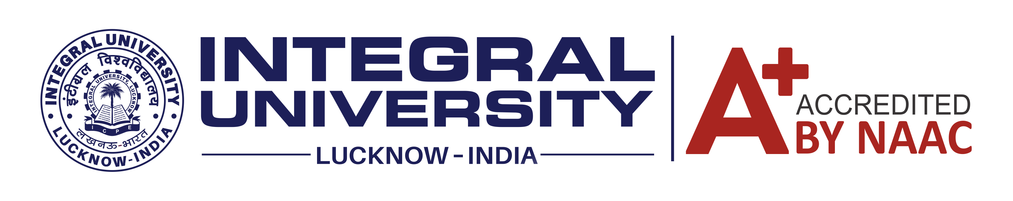
Center for Career Guidance & Development
Creating Possibilities.......Enabling Growth.

Notice

Campus Recruitment Drive

Company Name | Mzobs (https://mzobs.com/)  MZOBS is a technology-driven hiring and talent platform built to address the challenges of traditional recruitment, including unverified profiles, irrelevant applications, lengthy screening processes, and limited transparency. Our platform aims to create a trusted ecosystem where employers can connect with relevant talent through profile verification, structured screening, requirement validation, and skill-based matching- making the hiring process more efficient and seamless.
Date, Time | To be announced
Eligible Course | B Tech / MCA / BCA / B. Com / B. Sc. / BBA / MBA
Eligible Batch | 2026 / 2027
Job Profile | 1. HR Intern (Human Resources & Talent Operations)  2. IT Intern  3. Digital Marketing Intern
Package / Stipend | Sr. Executive: Rs. 15,000 – Rs. 20, 0000 per month  Executive: Rs. 10,000 – Rs. 15,000 per month  Intern: Rs. 3,000 – 5,000 per month for 3 months
Job Location | Lucknow
Job Description | Attached
Selection Process | Personal Interviews
Registration Step | https://forms.gle/XafJLXX9Hx1qcpXk9
Contact Person | Mr. Amir Khan (9795770027) - CCG&D, Integral University
Important Note | All eligible students are advised to register on the above links asap.

Date: 13th October, 2026 Director – CCG&D

Copy for kind information to:
HoDs (concerned) For information and departmental Notice Boards | Departmental Placement coordinators (Concerned)

